Jesus Nolazco

Chapter 6

**Try This 6_1**

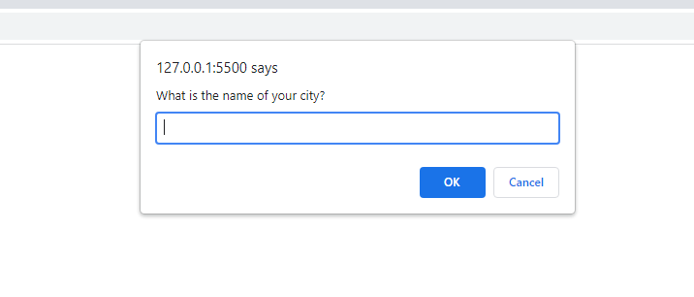

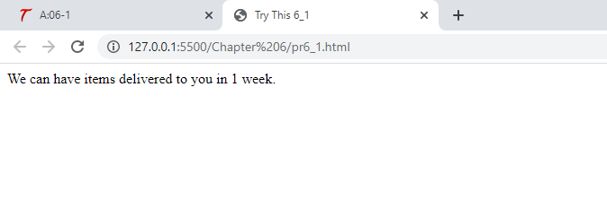

<!DOCTYPE html>

<html>

<head>

    <title>Try This 6_1</title>

</head>

<body>

    <script src="prjs6_1.js"></script>

</body>

</html>

let msg = "",

    city = window.prompt("What is the name of your city?", "");

if ((city === null) || (city === "")) {

    msg = "No City entered. Cannot determine delivery availability.";

} else {

    switch (city) {

        case "Johnstown":

            msg = "We can have the items delivered to you in 1 week.";

            break;

        case "Donville":

            msg = "We can have items delivered to you in 1 week.";

            break;

        case "Danieltown": // fall through

        case "Martytown":

            msg = "We can have items delivered to you in 2 weeks.";

            break;

        default:

            msg = "Sorry! We do not deliver to your city yet.";

    }

}

document.write(msg);

**Page 147 FOR Loop**

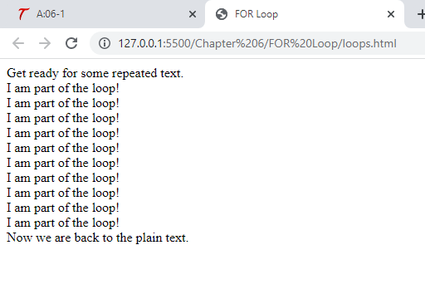

<!DOCTYPE html>

<html>

<head>

    <title>FOR Loop</title>

</head>

<body>

    <script src="loopsjs.js"></script>

</body>

</html>

document.write("Get ready for some repeated text.<br>");

for (let count = 1; count < 11; count++) {

    document.write("I am part of the loop!<br>");

}

document.write("Now we are back to the plain text.");

Page 150 Block nesting in pairs

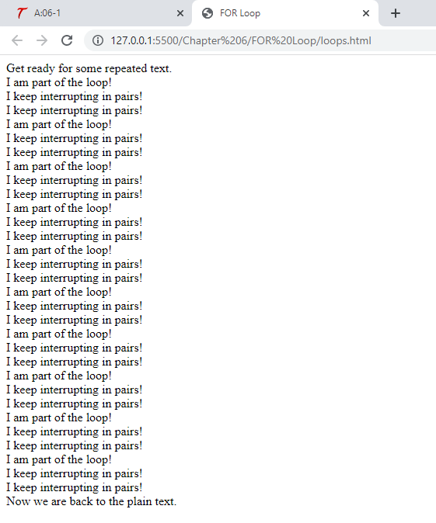

<!DOCTYPE html>

<html>

<head>

    <title>FOR Loop</title>

</head>

<body>

    <script src="loopsjs.js"></script>

</body>

</html>

document.write("Get ready for some repeated text.<br>");

for (let count = 1; count < 11; count++) {

    document.write("I am part of the loop!<br>");

    for (let nestcount = 1; nestcount < 3; nestcount++) {

        document.write("I keep interrupting in pairs!<br>");

    }

}

document.write("Now we are back to the plain text.");

**Page 152 Loop halfway done**

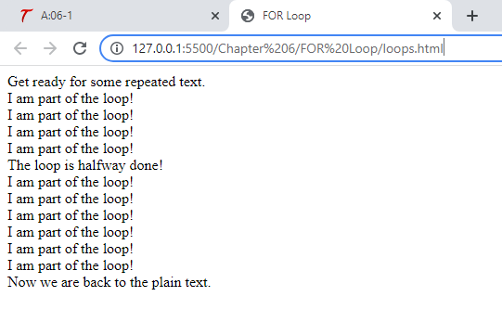

<!DOCTYPE html>

<html>

<head>

    <title>FOR Loop</title>

</head>

<body>

    <script src="loopsjs.js"></script>

</body>

</html>

document.write("Get ready for some repeated text.<br>");

for (let count = 1; count < 11; count++) {

    if (count === 5) {

        document.write("The loop is halfway done!<br>");

    }

    document.write("I am part of the loop!<br>");

}

document.write("Now we are back to the plain text.");

**Page 153 2nd Infinite FOR loop**

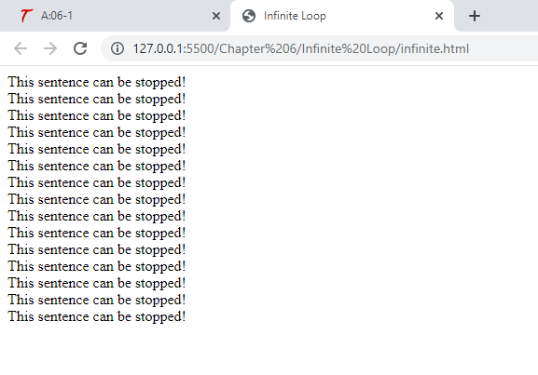

<!DOCTYPE html>

<html>

<head>

    <title>Infinite Loop</title>

</head>

<body>

    <script src="infinitejs.js"></script>

</body>

</html>

for (let i = 25; i > 10; i--) {

    document.write("This sentence can be stopped!<br>")

}

**Page 153 3rd Infinite FOR Loop**

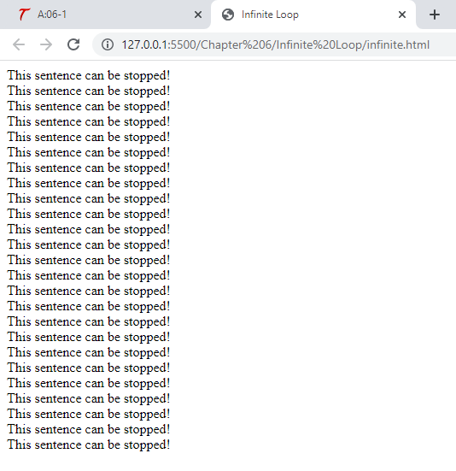

<!DOCTYPE html>

<html>

<head>

    <title>Infinite Loop</title>

</head>

<body>

    <script src="infinitejs.js"></script>

</body>

</html>

for (let i = 25; i < 50; i++) {

    document.write("This sentence can be stopped!<br>")

}

**Page 153 Multiple Statements**

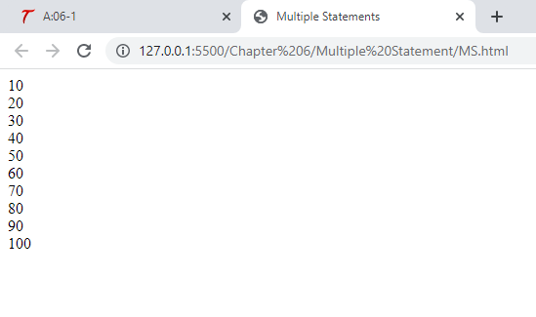

<!DOCTYPE html>

<html>

<head>

    <title>Multiple Statements</title>

</head>

<body>

    <script src="MSjs.js"></script>

</body>

</html>

for (let i = 1, j = 10; i < 11; i++, j += 10) {

    document.write(j + "<br>");

}

**Page 154 While Loop**

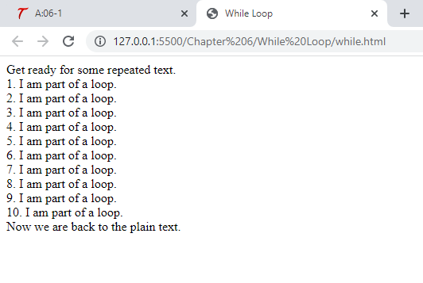

<!DOCTYPE html>

<html>

<head>

    <title>While Loop</title>

</head>

<body>

    <script src="whilejs.js"></script>

</body>

</html>

document.write("Get ready for some repeated text.<br>");

let count = 1;

while (count < 11) {

    document.write(count + ". I am part of a loop.<br>");

    count++;

}

document.write("Now we are back to the plain text.");

**Page 155 Do While Loop**

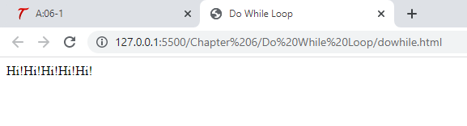

<!DOCTYPE html>

<html>

<head>

    <title>Do While Loop</title>

</head>

<body>

    <script src="dowhilejs.js"></script>

</body>

</html>

let count = 1;

do {

    document.write("Hi!");

    count++

} while (count < 6);

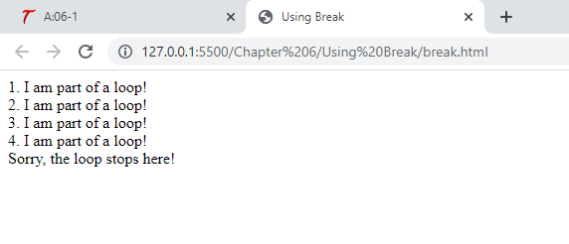**Page 156 Using break**

<!DOCTYPE html>

<html>

<head>

    <title>Using Break</title>

</head>

<body>

    <script src="breakjs.js"></script>

</body>

</html>

let stopnumber = 5

for (let count = 1; count < 11; count++) {

    if (count === stopnumber) {

        document.write("Sorry, the loop stops here!<br>");

        break;

    } else {

        document.write(count + ". I am part of a loop!<br>");

    }

}

**Page 156 Using continue  
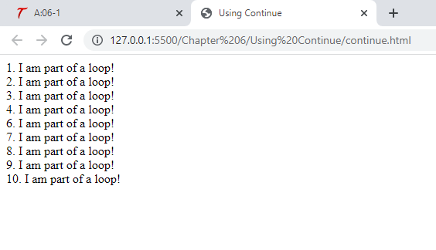**

<!DOCTYPE html>

<html>

<head>

    <title>Using Continue</title>

</head>

<body>

    <script src="continuejs.js"></script>

</body>

</html>

let skipnumber = 5;

for (count = 1; count < 11; count++) {

    if (count === skipnumber) {

        continue; // do nothing

    }

    document.write(count + ". I am part of a loop!<br>");

}

**Page 158 Try This 6-2**

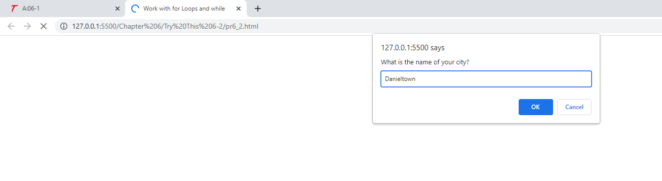

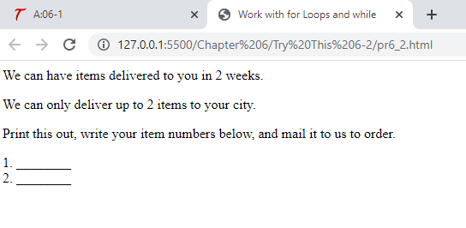

<!DOCTYPE html>

<html>

<head>

    <title>Work with for Loops and while</title>

</head>

<body>

    <script src="prjs6_2.js"></script>

</body>

</html>

let msg = "",

    city = window.prompt("What is the name of your city?", ""),

    items = 0

if ((city === null) || (city === "")) {

    msg = "No City entered. Cannot determine delivery availability.";

} else {

    switch (city) {

        case "Johnstown":

            msg = "We can have the items delivered to you in 1 week.";

            items = 10;

            break;

        case "Donville":

            msg = "We can have items delivered to you in 1 week.";

            items = 5;

            break;

        case "Danieltown": // fall through

        case "Martytown":

            msg = "We can have items delivered to you in 2 weeks.";

            items = 2;

            break;

        default:

            items = 0

            msg = "Sorry! We do not deliver to your city yet.";

    }

}

document.write(msg);

if (items > 0) {

    document.write(

        "<p>We can only deliver up to " + items + " items to your city.</p>");

    document.write(

        "<p>Print this out, write your item numbers below, and mail it to us to order.</p>");

    for (let count = 1; count <= items; count++) {

        document.write(count + ". ________<br>");

    }

}